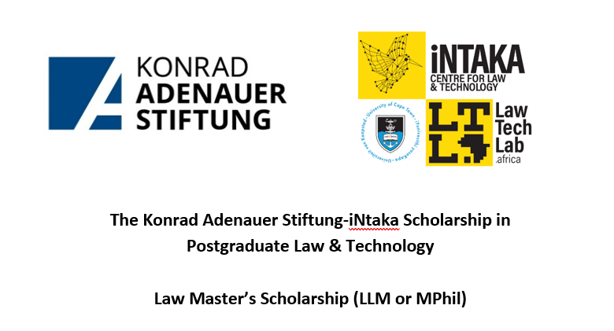
APPLICATION FORM
PLEASE READ THROUGH THE CALL FOR APPLICATIONS BEFORE COMPLETING THIS APPLICATION FORM.

Eligibility criteria
- Applicants must meet the entry requirements for a full-time LLM or MPhil at the UCT’s Faculty of Law.
- Applicants must be able to demonstrate a proven interest in Law & Technology, as an area of interest and study.
- Applicants must be intending to undertake Master’s-level study on a full-time basis, and must be able to contribute to the work of iNtaka Centre for Law & Technology, under the supervision of the Centre’s director.
- Applicants must be willing to be based in Cape Town for the duration of the scholarship.
- If not South African, or a permanent resident in South Africa, applicants must have (or be applying for) a valid study permit.

- *Please note that the UCT Faculty of Law does not offer a Master’s Programme in Law & Technology, and that the purpose of this scholarship is to support a UCT Law Master’s student with a demonstrated interest in the field of Law & Technology.
If you believe you are eligible to apply, please complete the form below.

Surname: ……………………………………………First name: ………………………………………………………………………

Residential home address: ……………………………………………………………………………………………………………..

………………………………………………………… Contact tel / cell no: …………………………………………………

E mail address: ………………………………………………………………………………………………………………………………..

Student No/ UCT reference: …………………………………

SA Identity no./ Passport number: ……………………………………………………

Self-declared race classification:…………………………………………………….

Gender: ………………………………………………………………………………………….

Intended UCT Law Master’s Programme ……………………………………………………………………………………

Have you received a firm offer of a place on a UCT Law Master’s Programme yet? Y/N……………………

Signature: ……………………………………………….. Date: …………………………
APPLICATION CHECKLIST
- Completed application form.
- A cover letter with motivation (one page or less) for the application, outlining your legal interests, including clear indications of an interest in Law & Technology. This motivation must also address your suitability for the research assistant role.
- A full CV.
- Two written references from contactable referees.
- Copies of all academic qualifications.
- Mid-year academic results and/or academic transcript of previous degree.

Please note that any application that does not include all of these items submitted as a SINGLE pdf will be considered incomplete and therefore invalid.

NOTES:
- Please submit by email to law-marketing@uct.ac.za by 7 November 2025, along with your most recent academic transcript.
- Late and/or incomplete applications will not be considered.
- Scholarship payments are made directly into a student’s fee account.
- Please note that should you receive other funding support, it is possible that your scholarship award may be reversed, or the university may adjust any other university support you receive. Any other funding support would need to be declared to the Law Faculty.
- Applicants shortlisted for this scholarship may be called to an interview (30 mins), which could be conducted online.

