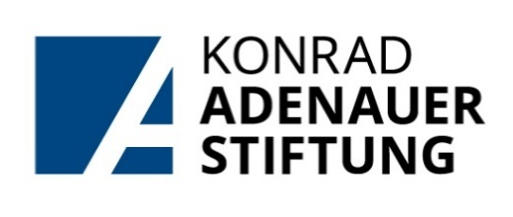
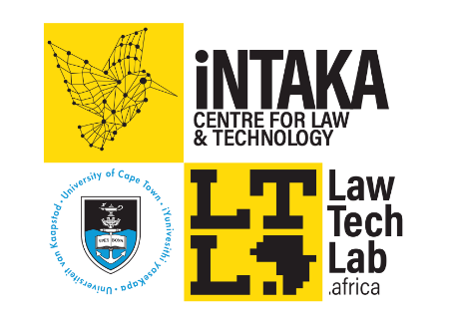

The Konrad Adenauer Stiftung-iNtaka Scholarship in
Postgraduate Law & Technology

Law Master’s Scholarship (LLM or MPhil)

CALL FOR APPLICATIONS for 2026

The Konrad Adenauer Foundation (KAS) and the University of Cape Town Law Faculty’s iNtaka Centre for Law & Technology invite applications for a one-year LLM/MPhil Scholarship for 2025.

This scholarship includes a substantial contribution to tuition fees, as well as a paid short-term research assistant position at iNtaka Centre for Law & Technology for 11 months (Feb – Dec 2025). The objective of this Law Master’s Scholarship Programme is to build capacity in the Law & Technology space, and to contribute to the growth of UCT Law’s expertise in this field.

*Please note that the UCT Faculty of Law does not offer a Master’s Programme in Law & Technology, and that the purpose of this scholarship is to support a UCT Law Master’s student with a demonstrated interest in the field of Law & Technology.

Requirements

Prerequisites for an award are outstanding academic performance, personal suitability, political and social commitment, as well as the readiness to play an active role to benefit from and develop relationships between the candidate’s home country and the Federal Republic of Germany. We expect candidates to have a broad general education and a strong interest in political issues, a positive attitude towards democracy and human rights, and to exercise tolerance with regard to different-minded people.
- The successful applicant (hereafter scholarship holder) would have to meet the entry requirements for a full-time LLM or MPhil at the University of Cape Town’s Faculty of Law.
- The scholarship holder must comply with all academic rules of UCT (institutional) and the Faculty of Law as applicable to postgraduate students.
- The scholarship holder must demonstrate a proven interest in Law & Technology, as an area of interest and study.
- The scholarship holder is expected to undertake Master’s-level study on a full-time basis, while contributing to the work of iNtaka Centre for Law & Technology, under the supervision of the centre’s director.
- The scholarship holder is expected to be based in Cape Town for the duration of the scholarship.
- If not South African, or a permanent resident in South Africa, the scholarship holder must have a valid study permit.
- The duration of the scholarship is February-December for a maximum period of one year.
- The research assistant role will include, broadly, providing scholarly and administrative support for the Centre by (amongst other responsibilities):
    - compiling literature reviews
    - co-writing blog posts, peer-reviewed articles and media materials
    - managing and contributing to the iNtaka Centre for Law & Technology’s social media accounts
    - helping to plan and execute events and webinars
    - assisting the iNtaka team with the execution of the centre’s various projects.

Application Process

Prospective students must apply via email to law-marketing@uct.ac.za by 7 November 2025.

Applications must include the following, all combined into a SINGLE pdf document:
- A completed application form – available on the Law Faculty website
- A cover letter with motivation (one page or less) for the application, outlining the applicant’s legal interests, and including clear indications of an interest in Law & Technology. This motivation must also address the applicant’s suitability for the research assistant role.
- A full CV
- Two written references from contactable referees.
- Certified copies of all academic qualifications.
- Mid-year academic results and/or academic transcript of previous degree.

*Please note that applications NOT submitted as a single pdf document will be considered incomplete and will not be considered.
Shortlisted candidates will be invited for an interview that may be conducted online or in-person (to be determined). All applicants will receive notification of the outcome of the application.
PLEASE NOTE: no late or incomplete applications will be accepted.

