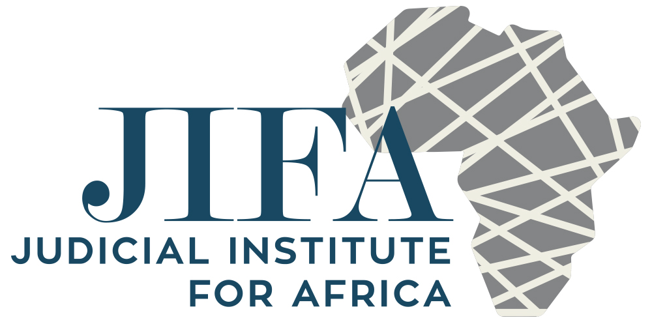

**JUDICIAL LEADERSHIP COURSE**

**YEAR ONE**

**DEPTH LEADERSHIP, THE RULE OF LAW AND SEPARATION OF POWERS, AND JUDICIAL GOVERNANCE**

**Sunday 23rd July 2017**

7pm. Welcome dinner

**Day One – Monday 24th July 2017**

Depth Leadership – Helene Smit

**Day Two** – **Tuesday 25th July 2017**

Depth Leadership – Helene Smit

**Day Three – Wednesday 26th July 2017**

The Rule of Law and the Separation of Powers

Corruption

The responsibilities of the Chief Justice and other senior members of the judiciary.

Creating an office of the judiciary

**Faculty lead: Justice Moseneke**

9.00 Registration- collection of materials

PLENARY

9.15 Introduction/administrative matters (LD/VK)

9.30 Video talk “Rule of Law and the Separation of Powers” Lord Thomas, LCJ of England and Wales

9.55 Talk/Discussion - “The Rule of Law and Separation of Powers – An African perspective” (DM).

Coffee to be taken at a convenient point during the session.

12.00 “Judicial Corruption – fact or fiction?”

This session will feature a film of reported examples of judicial corruption. This will be followed by discussion about “what constitutes corruption and what measures are needed to reduce/ eliminate the risk of corruption.

13.30 LUNCH

PLENARY

14.30 Judicial Governance structures in the US, UK, SA, Kenya and Malawi (KP/LD/DM/WM/AN)

BREAKOUT GROUPS

15.00 To discuss: a) the robustness of the governance structures in individual jurisdictions b) The responsibilities of Chief Justices and other senior Judges and c) Creating an office of the Chief Justice. (Tea to be taken during the break out session)

(Some research on how different jurisdictions operate will be provided to the participants. The discussion will focus on what the essential structures and processes need to be in place to support Chief justices and senior judges carry out their responsibilities. By the end of the discussion, guidance/templates will be prepared, if necessary, to assist those jurisdictions which lack the necessary infrastructure to function efficiently).

PLENARY

16.30 Feedback from the break out groups

17.15 Finish

**Day Four – Thursday 27th July 2017**

External Relationships: a) Executive and Legislature; b) Legal fraternity; c) other players in the justice system; d) media and public

**Faculty Lead: Justice Matunga/Justice Nyirenda**

9.00 Introduction, raising the issues which will be discussed during the course of the day and in light of the talk on the separation of powers and judicial independence. (WM)

BREAK OUT GROUPS

9.30 Executive and Legislature. 2 case scenarios for discussion

10.30 The Legal Fraternity. 2 case scenarios for discussion

(COFFEE to be taken during the break- out sessions)

PLENARY

12.00 Feedback from the break out groups. (WM as moderator)

13.00 LUNCH

BREAKOUT GROUPS

14.00 Other players in the justice system – case scenarios for discussion

14.45 The media and the public – case scenarios for discussion

PLENARY

15.45 Feedback from break out groups (AN to act as moderator)

16.45 Finish

**At dinner: Professor Penny Andrews in conversation with Justice Sonia Sotomayor**

**Day Five – Friday 28th July 2017**

Internal relationships a) judicial governance structures; b) managing the judges and court staff: procedural fairness and transparency, HR and grievance policies and procedures; c) judges’ associations; judicial well-being; d) relationships with the Magistracy

**Faculty lead: Judge Peters/Justice Nyirenda**

9.00 Managing judges and court staff – policies and procedures – the US experience (KP)

9.45 Managing judges and court staff – some African experiences (AN/WM)

11.00 COFFEE

11.30 Discussion arising from above talk. (KP to act as moderator)

12.30 LUNCH

13.30 Talk: Judges associations, judicial well-being – the US/UK experience. (KP/LD)

14.00 Discussion on the African experience (AN to moderate)

15.00 Talk and discussion: Relationship with the Magistracy (AN)

15.30 Pulling strings together. Looking forward. (LD)

16.00 Finish