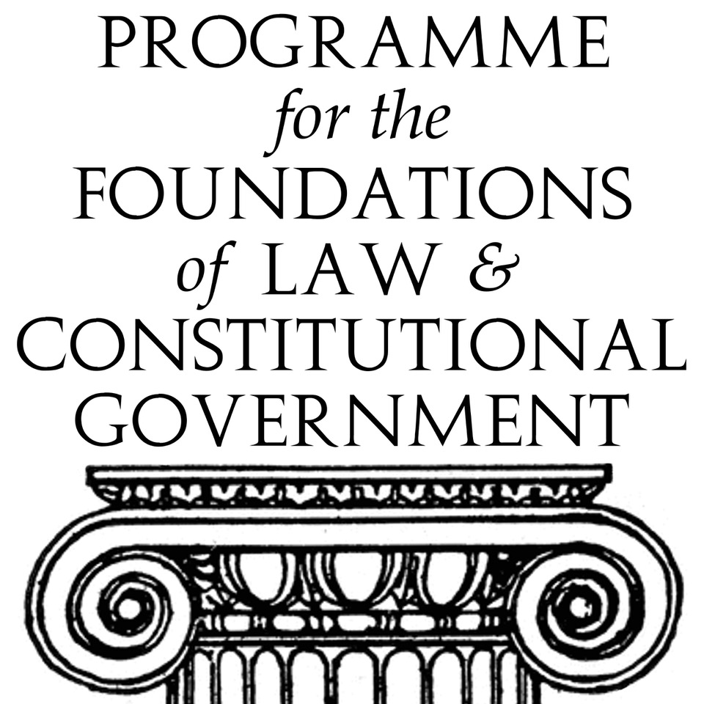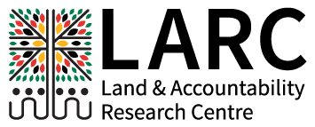

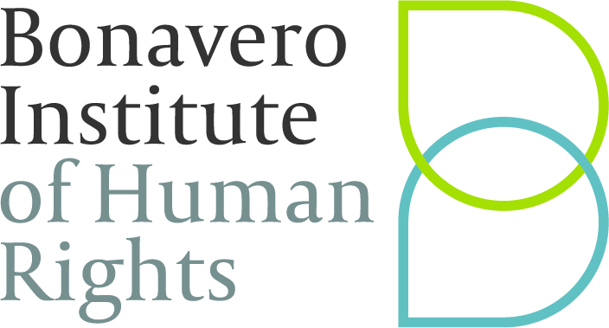

**Citizenship and Accountability: Litigating Customary Law and Traditional Leadership under South Africa’s Democratic Constitution**

**Monday 17th and Tuesday 18th June 2019**

**Gilly Leventis Meeting Room**

**Bonavero Institute of Human Rights**

**University of Oxford**

**It is twenty-five years since the transition to democracy in South Africa. Some of the most enduring challenges to that transition have been the question of the role of customary law and traditional leadership in the new democratic state. During 2018, Parliament debated the Traditional and Khoi-San Leadership Bill and it is likely that the Bill will come into force soon. In addition, a series of important decisions concerning customary law and the role of traditional leaders under South Africa’s democratic Constitution was delivered (*Maledu and Others v Itereleng Bakgatla Mineral Resources (Pty) Limited and Another*** (CCT265/17) [2018] ZACC 41; ***Rahube v Rahube and Others*** (CCT319/17) [2018] ZACC 42 (30 October 2018) **and** ***Baleni and Others v Minister of Mineral Resources and Others*** (73768/2016) [2018] ZAGPPHC 829 (22 November 2018) and ***Gongqose and others v Minister of Agriculture, Forestry and Others*** (1340/17, 287/17) [2018] ZASCA 87 (1 June 2018). **Given these developments, it is an opportune moment to hold a round-table symposium to discuss the questions that citizenship and accountability under customary law and traditional leadership pose for South Africa’s new democratic order, and in particular, the manner in which these issues are being litigated in South African courts. The symposium will draw together scholars, practitioners and judges. It will form part of the Bonavero Institute of Human Rights’ Emerging Scholars programme that seeks to draw together emerging scholars, particularly from the global South, and senior scholars. It will be co-hosted by the Programme for the Foundations of Law and Governance and Constitutional Government in Oxford, and the Land and Accountability Research Centre at the University of Cape Town.**

**Revised Programme**

**Monday 17th June 2019**

9.30 – 11.00 Where we are now? The Constitution, Traditional Leaders and Customary Law

Chair: Kate O’Regan

Customary law and traditional leadership within the constitutional framework: Yvonne Mokgoro (TBC)

Historical overview: Peter Delius (confirmed)

The Bills: Aninka Claassens (confirmed)

11.00 – 11.30 Tea

11.30 – 12.45 What is living customary law? And how should the Courts identify it and apply it?

Chair: Nick Barber

Professor Thandabantu Nhlapo (confirmed)

Nolundi Luwaya (confirmed)

Kate O’Regan (confirmed)

12.45 – 2.00 Lunch

2.00 – 3.15 Mining and Resources: issues arising from recent litigation

Chair: Nolundi Luwayo

IPILRA (Xolobeni and Maledu): Johan Lorenzen (confirmed)

Fishing: Gongqose judgment: Michael Bishop (possibly via Skype)

Wild Coast Sun: William Beinart (confirmed)

A Perspective from Ghana: Cynthia Kwakyewah (confirmed)

3.15 – 3.45 Tea

3.45 – 5.30 Traditional Leaders, Money and accountability

Chair: Jonny Steinberg

Accountability of chiefs in customary law: John Comaroff (confirmed)

Lessons from the Maluleke/Baloyi Commission: Wilmien Wicomb (confirmed)

D Accounts in North West: Stanley Malindi (confirmed)

**Tuesday 18th June 2019**

9.30 – 11.15 The scope of chiefly power

Chair: Jason Brickhill

Comparative Overview: Janine Ubink

The new legislation and its fit with the constitutional framework: Michael Mbikiwa (confirmed)

Conferral of power to perform state functions on chiefs: Monica De Souza Louw (confirmed)

A perspective from Ghana: Maame Mensa Bonsu (confirmed)

11.15 – 11.45 Tea

11.45 – 1.30 The History and Nature of Land Rights in Africa

Chair: Ben Cousins

Thuto Thipe (confirmed)

Mary Jiyani (confirmed)

Michelle Hay (confirmed)

Derick Fay (confirmed)

Dominic Burbidge (confirmed)

1.30 – 2.3o Lunch

2.3o – 4.15 The way forward

Chair: Thandabantu Nhlapo

Geoff Budlender (confirmed)

Tembeka Ngcukaitobi (confirmed)

Constance Mogale (TBC)